**MICROCONTROLLERS PROJECT**

**THERMOSTAT CIRCUIT DESIGN**

Student: Uriciuc Mihai

Group: 2031 / Semigroup II

Table of Contents

1.Block Scheme 3

2.The temperature sensor 3

2.1. Analog temperature sensors categories 3

**2.1.1. Thermistors** 3

**2.1.2. Thermocouples** 3

**2.1.3. RTDs (Resistance Temperature Detectors)** 3

**2.1.4. Analog Output IC Sensors** 3

2.2. The chosen sensors 4

**2.2.1. LMT70** 4

**2.2.2. YSI 44031** 4

**2.2.3. LM35 (National Semiconductor / Texas Instruments)** 5

# 1.Block Scheme

Temperature sensor

Display

Microcontroller

Keyboard

Execution element

# 2.The temperature sensor

## 2.1. Analog temperature sensors categories

To restrain the area for finding the perfect resistor for my thermostat I will use an analog temperature sensor. Why an analog sensor? Because analog sensor are easier to use, they have a faster response time and have a lower cost. The signal at the output of the sensor is continuous and directly proportional to the temperature.

Next, I will briefly explain the 4 categories of analog temperature sensors.

### **2.1.1. Thermistors**

Thermistors are made of semiconductor materials and their resistance changes with temperature. There are two types of thermistors, NTC(Negative Temperature Coefficient – the resistance decreases as temperature increases) and PTC(Positive Temperature Coefficient - resistance increases as temperature increases).

### **2.1.2. Thermocouples**

Thermocouples are made of two different metals joined together.When these metals heated or cooled, they generate a small voltage (called the Seebeck effect), which is proportional to the temperature.

### **2.1.3. RTDs (Resistance Temperature Detectors)**

RTDs measure temperature by correlating the resistance of a metal (usually platinum) with temperature. As temperature increases, the resistance of the metal increases in a predictable way.

### **2.1.4. Analog Output IC Sensors**

These are integrated circuits (ICs) that measure temperature and provide a linear analog output (voltage or current) proportional to the temperature. They often include built-in signal conditioning.

## 2.2. The chosen sensors

The specifications for our sensor are: 5-30°C operating range, ±0.2°C precision.

From the categories above, I picked 5 possible sensors for my thermostat.

### **2.2.1. LMT70**

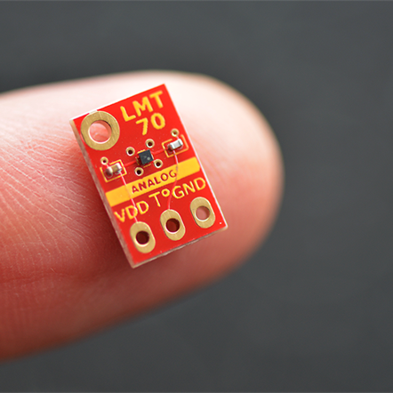 This is an Analog IC sensor, with a high precision ±0.2°C (max) from -20°C to 90°C, which is perfect for my thermostat from the specifications point of view. It has a low power supply current, 9.2 µA (typ)12 µA (max), a wide power supply range of 2V-5.5V and it is very small, 0.88 mm by 0.88 mm. Also it is already calibrated for °C . The downsides are the price, it is pretty expensive, 12 dollars a piece, the voltage output is in millivolts so it is going to need an amplifier for a better signal.

### **2.2.2. YSI 44031**

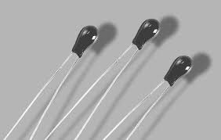 This one is a thermistor, more specifically a Pressed Disk Ceramic Sensor, who also has a high precision of ±0.1°C from 0°C to 70°C, it is very sensitive, it is also very small (0.095″ (2.4 mm) Maximum Diameter). As disadvantages, it has  **non-linear response, unlike** LMT70 or LM35 (which I will present later)**,** which means it needs special calibration and compensating circuits. This thermistor is also expensive, one piece being 16 dollars.

### **2.2.3. LM35 (National Semiconductor / Texas Instruments)**

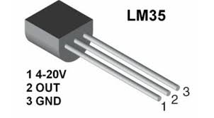 This one is also an Analog IC Sensor, just like LMT70, but is very low cost 1 euro a piece or less than that, it is widely available, operates from

-55°C to 150°C and it Outputs a linear analog voltage (10mV per °C). It operates from 4V to 40V and consumes less than 60μA. The bad part about this sensor is that the precision is ±0.5°C.

## 2.3. The sensor for the thermostat.

Between these three resistors that I picked, the LMT70 is the best choice for my project. It has both the range and precision, it is already calibrated and it is very small. The YSI 44031 thermistor is also a really good choice, but these two have something in common that is crucial for my project. Both of them don’t exist in Proteus 8 library, and because that is the program required for the project I will have to pick LM35. In my thermostat I really want to use a Analogic IC sensor for its simplicity, so the LM35 is the next best choice after LMT70. I know that it doesn’t meet the specification but in the datasheet is specified that at room temperature it has a precision of ±0.25°C, so that sure helps.

LM35 Datasheet: https://www.ti.com/lit/ds/symlink/lm35.pdf